Experiment: BREAKING RSA SOMILA. SA

231901052

AIM: Hop in and break poorly implemented RSA using Fermat's factorization algorithm.

PROCEDURE:

• Task 1: Capture the flag

Task 1: Capture the flag

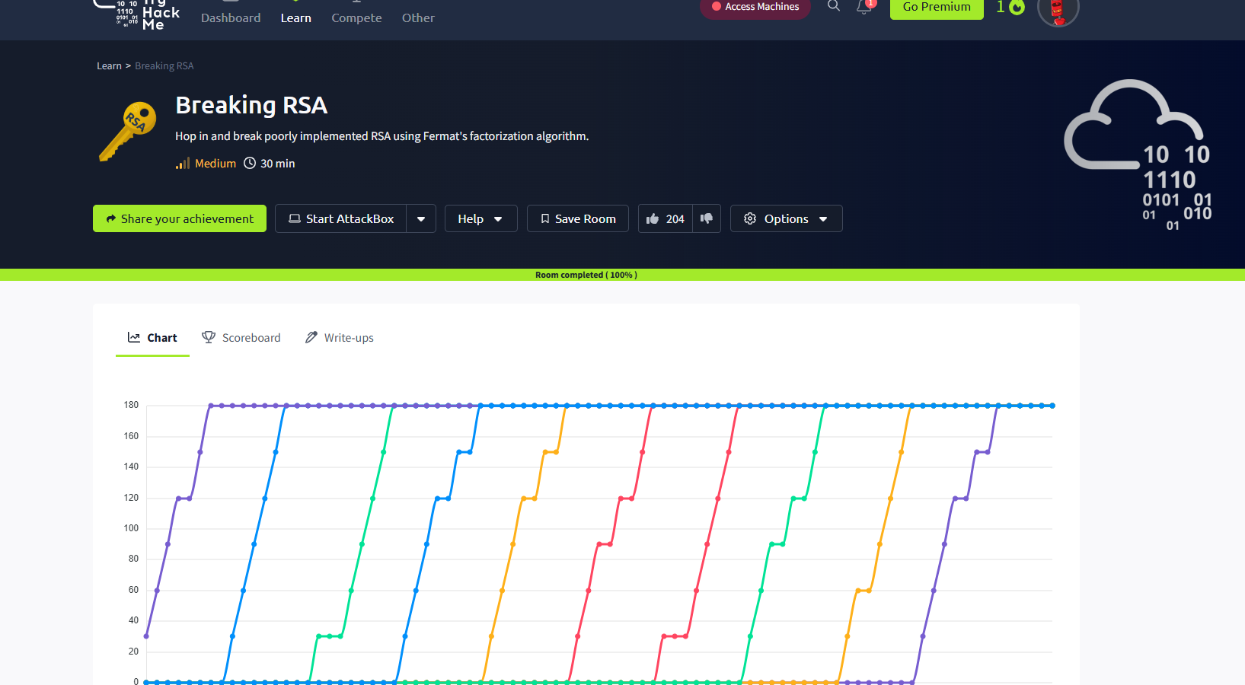

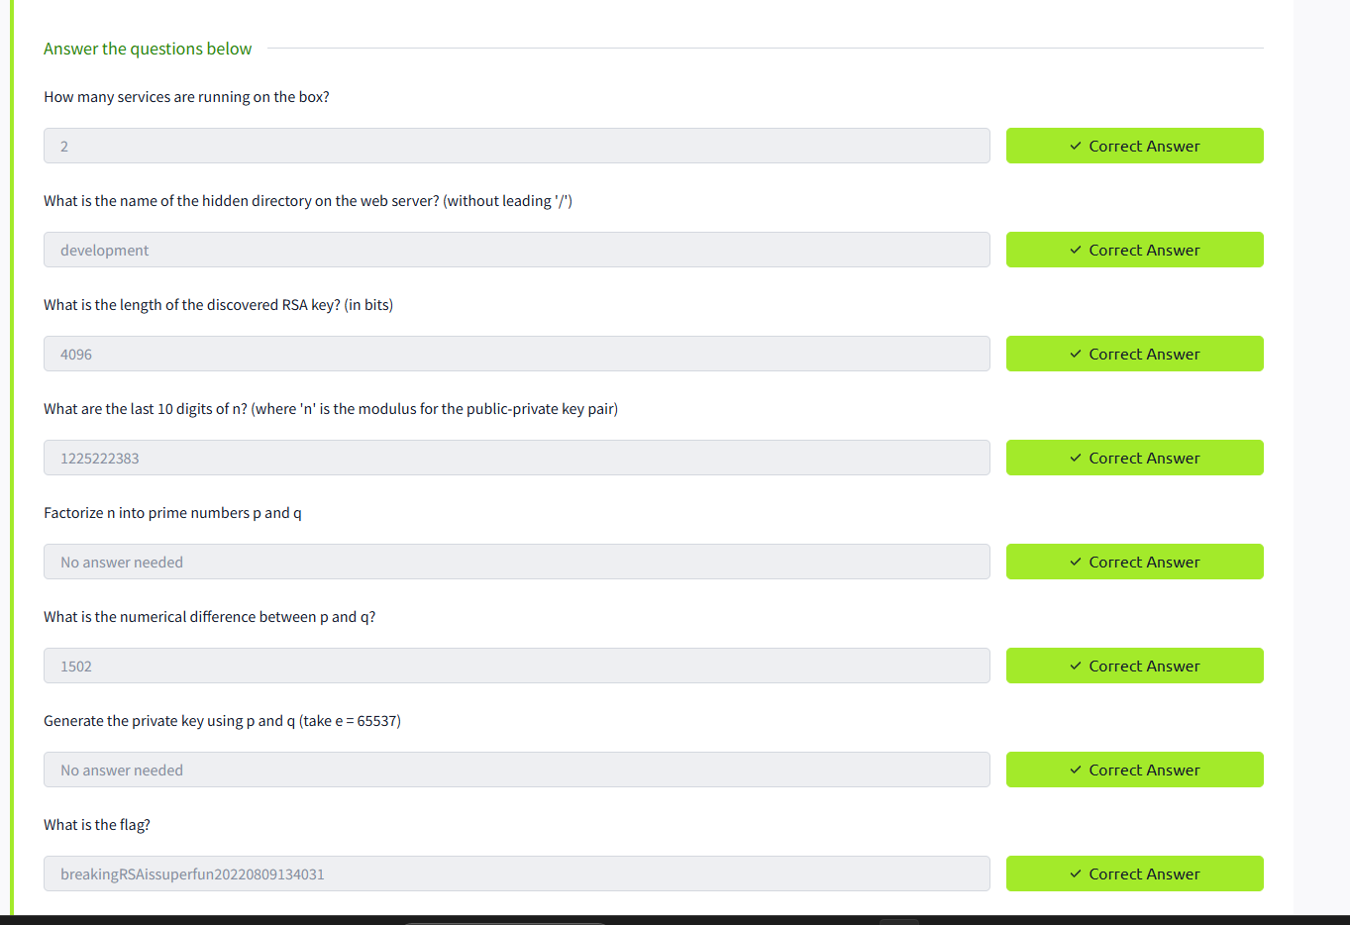

RESULT: Thus the Breaking RSA is successfully completed in tryhackme platform.